Objectives
- Extract: Load the raw supply chain dataset from a CSV file.
- Transform: Clean, standardize, and structure the data into a star schema with dimension and fact tables.
- Load: Store the transformed data into CSV files and import them into a SQL Server database.
- Database Creation: Define a relational database schema with appropriate tables, primary keys, foreign keys, constraints and indexes.
- Enable Analytics: Create a data warehouse structure optimized for analytical queries.

Platform and Tools
- Google Colab: Cloud-based Jupyter Notebook environment for ETL processing using Python.
- Python Libraries:
  - Pandas: For data manipulation and transformation.
  - NumPy: For numerical operations.
- MS Azure SQL Server: Relational database management system for storing the data warehouse.
- SQL Server Management Studio (SSMS): For database creation, schema definition, and data import.
- Dataset: https://www.kaggle.com/datasets/shashwatwork/dataco-smart-supply-chain-for-big-data-analysis/code, containing supply chain transactional data.

3. Methodology
The project follows a structured ETL process and database creation workflow:
- Data Extraction: Read the raw dataset from a CSV file stored in Google Drive.
- Data Transformation: Clean the data, remove redundancies, handle missing values, and create dimension and fact tables.
- Data Loading: Export transformed data to CSV files and import them into SQL Server tables.
- Database Creation: Define the database schema, including tables, primary keys, foreign keys, constraints and indexes.
- Verification: Ensure data integrity and consistency through checks and previews.
The data warehouse adopts a star schema, with a central fact table (FactOrderItem) linked to multiple dimension tables (DimCustomer, DimProduct, DimDepartment, DimLocation, DimShipping, DimOrderStatus, DimTransactionType, DimDate).

4. ETL Process
The ETL process is implemented in a Jupyter Notebook (Supplychain.ipynb) using Python in Google Colab. Below is a detailed breakdown of each step.

4.1. Extract
- Source: The dataset DataCoSupplyChainDataset.csv is stored in Google Drive under the directory /content/drive/MyDrive/Colab Data/BI and ML.
- Access: Google Drive is mounted using the google.colab.drive module, and the working directory is set to the appropriate path.
- Loading: The dataset is loaded into a Pandas DataFrame using pd.read_csv() with latin-1 encoding to handle special characters.
Code Snippet:
from google.colab import drive
drive.mount('/content/drive')
import pandas as pd
import numpy as np
df = pd.read_csv('DataCoSupplyChainDataset.csv', encoding='latin-1')

4.2. Transform
The transformation phase involves cleaning, standardizing, and structuring the data into a star schema.

4.2.1. Data Cleaning
- Remove Unnecessary Columns: Drop columns irrelevant for analysis, such as Product Description, Product Image, Customer Password, Customer Email, Customer Fname, Customer Lname, and Order Zipcode.
- Remove Duplicate Columns: Validate and drop redundant columns (Order Customer Id, Order Item Cardprod Id) after confirming they are identical to CustomerId and ProductCardId.
- Standardize Column Names: Replace spaces with empty strings and rename columns for clarity (e.g., Daysforshipping(real) to DaysForShippingReal).
- Handle Missing Values: Fill missing CustomerZipcode values with the string "0.0".
- Convert Date Columns: Convert orderdate(DateOrders) and shippingdate(DateOrders) to datetime format using pd.to_datetime().
- Round Numeric Columns:
  - Monetary columns (e.g., Benefitperorder, Sales) are rounded to 2 decimal places.
  - Ratio columns (e.g., OrderItemDiscountRate, OrderItemProfitRatio) are rounded to 6 decimal places.

Code Snippet:

cols_to_drop = ['Product Description', 'Product Image', 'Customer Password', 'Customer Email', 'Customer Fname', 'Customer Lname', 'Order Zipcode']
df = df.drop(columns=[col for col in cols_to_drop if col in df.columns])
if (df['Customer Id'] == df['Order Customer Id']).all():
df = df.drop(columns=['Order Customer Id'])
df.columns = df.columns.str.replace(' ', '')
df['CustomerZipcode'] = df['CustomerZipcode'].fillna('0.0')
df['orderdate(DateOrders)'] = pd.to_datetime(df['orderdate(DateOrders)'])
df[two_decimals] = df[two_decimals].round(2)

4.2.2. Dimension Table Creation
Eight-dimension tables are created by selecting unique records:
- DimCustomer: Contains CustomerId, CustomerSegment, CustomerCountry, CustomerState, CustomerCity, CustomerStreet, CustomerZipcode.
- DimProduct: Contains ProductCardId, ProductCategoryId, CategoryName, ProductName, ProductPrice, ProductStatus.
- DimDepartment: Contains DepartmentId, DepartmentName, Market.
- DimLocation: Contains OrderRegion, OrderCity, OrderState, OrderCountry,.
- DimShipping: Contains ShippingMode, DaysForShippingReal, DaysForShipmentScheduled.
- DimOrderStatus: Contains OrderStatus.
- DimTransactionType: Contains Type.
- DimDate: Created from unique dates in orderdate(DateOrders) and shippingdate(DateOrders), with attributes DateId, Year, Quarter, Month, MonthName, Day, DayOfWeek, DayName.
Code Snippet:
dim_customer = df[[
'CustomerId', 'CustomerSegment', 'CustomerCountry', 'CustomerState',
'CustomerCity', 'CustomerStreet', 'CustomerZipcode'
]].drop_duplicates().reset_index(drop=True)
4.2.3. Fact Table Creation
The FactOrderItem table is the central fact table in the star schema, storing transactional data and linking to dimension tables via natural keys in the ETL process. Surrogate keys (FactOrderItemId, LocationId, ShippingId, OrderStatusId, TransactionTypeId) are generated in SQL Server using the IDENTITY property during data import.
The FactOrderItem table is created by:
fact_orderitem = df[[
'OrderId','OrderItemId','CustomerId','ProductCardId','DepartmentName', 'Market','OrderCity', 'OrderState', 'OrderCountry',
'ShippingMode', 'DaysForShippingReal', 'DaysForShipmentScheduled', 'OrderStatus','Type','orderdate(DateOrders)', 'shippingdate(DateOrders)','OrderItemQuantity','OrderItemDiscount','OrderItemDiscountRate','OrderItemProductPrice',
'OrderItemProfitRatio','Sales','OrderItemTotal','Benefitperorder','OrderProfitPerOrder','DeliveryStatus','Late_delivery_risk'

]].drop_duplicates().reset_index(drop=True)
fact_orderitem.to_csv('FactOrderItem.csv', index=False)
print("Fact table exported.")

Process:
- Select relevant columns from the DataFrame, including:
  - Identifiers: OrderId, OrderItemId, CustomerId, ProductCardId.
  - Natural keys for dimensions:
    - Department: DepartmentName, Market.
    - Location: OrderCity, OrderState, OrderCountry.
    - Shipping: ShippingMode, DaysForShippingReal, DaysForShipmentScheduled.
    - Order Status: OrderStatus.
    - Transaction Type: Type.
    - Date: orderdate(DateOrders), shippingdate(DateOrders).
  - Metrics: OrderItemQuantity, OrderItemDiscount, OrderItemDiscountRate, OrderItemProductPrice, OrderItemProfitRatio, Sales, OrderItemTotal, Benefitperorder, OrderProfitPerOrder.
  - Attributes: DeliveryStatus, Late_delivery_risk.
- Remove duplicate records using drop_duplicates() to ensure data integrity.
- Export the table to FactOrderItem.csv for SQL Server import.
- Natural Key Approach: Unlike dimension tables with pre-existing IDs (e.g., CustomerId, ProductCardId), the fact table uses natural keys for DimLocation, DimShipping, DimOrderStatus, DimTransactionType, and date fields. These are mapped to auto-generated surrogate keys during the SQL Server import process.
- Date Handling: The orderdate(DateOrders) and shippingdate(DateOrders) columns are retained as full timestamps in the CSV, to be matched with DateId in DimDate during import.

4.3. Load
The loading process populates the SupplyChain database by transferring data from CSV files generated by the ETL process into SQL Server tables. Staging tables are used for all dimension tables and the fact table to facilitate data validation and transformation. The SSMS Import Data Wizard is employed to import CSVs into staging tables, followed by INSERT INTO statements to move data into final tables, mapping natural keys to surrogate keys where applicable. Dimension tables are loaded first to satisfy foreign key constraints in FactOrderItem.
Dimension Table Loading:
- Export to CSV: The ETL process exports dimension tables to CSV files using to_csv() in Pandas, ensuring unique records via drop_duplicates().
- Staging Tables: Create staging tables with structures matching the CSVs.
- Import via SSMS: Use the SSMS Import Data Wizard to load each CSV into its staging table:
    - Select the CSV file as the source and the staging table as the destination.
  - Map CSV columns to staging table columns, skipping headers.
  - Execute the import, validating data types.
- Insert into Final Tables: Use INSERT INTO statements to transfer data from staging to final tables, allowing SQL Server to assign IDENTITY keys for DimLocation (LocationId), DimShipping (ShippingId), DimOrderStatus (OrderStatusId), and DimTransactionType (TypeId).
- Verification: Check row counts and sample data (e.g., SELECT COUNT (*) FROM DimCustomer) to ensure successful loading.
- Cleanup: Drop the staging tables after insertion.

Fact Table Loading:
- Export to CSV: The FactOrderItem table is exported to FactOrderItem.csv, containing natural keys and metrics.
- Staging Table: Create a staging table (FactOrderItemDF) matching the CSV structure.
- Import via SSMS: Use the SSMS Import Data Wizard to load FactOrderItem.csv into FactOrderItemDF, mapping columns and validating data.
- Mapping Natural Keys: An INSERT INTO statement maps natural keys to surrogate keys by joining FactOrderItemDF with dimension tables:
  - DepartmentName, Market → DepartmentId (from DimDepartment).
  - OrderCity, OrderState, OrderCountry → LocationId (from DimLocation).
  - ShippingMode, DaysForShippingReal, DaysForShipmentScheduled → ShippingId (from DimShipping).
  - OrderStatus → OrderStatusId (from DimOrderStatus).
  - Type → TypeId (from DimTransactionType).
  - orderdate_DateOrders, shippingdate_DateOrders → OrderDateId, ShippingDateId (from DimDate).
- Surrogate Key Assignment: SQL Server assigns FactOrderItemId via IDENTITY.
- Cleanup: Drop the staging table (FactOrderItemDF) after insertion.
Code Snippet:
dim_customer.to_csv('DimCustomer.csv', index=False)
dim_product.to_csv('DimProduct.csv', index=False)
fact_orderitem.to_csv('FactOrderItem.csv', index=False)

SQL Snippet:
INSERT INTO dbo.FactOrderItem (
OrderId, OrderItemId, CustomerId, ProductCardId, DepartmentId,
LocationId, ShippingId, OrderStatusId, TypeId,
OrderDateId, ShippingDateId, OrderItemQuantity, OrderItemDiscount,
OrderItemDiscountRate, OrderItemProductPrice, OrderItemProfitRatio,
Sales, OrderItemTotal, Benefitperorder, OrderProfitPerOrder,
ProfitPerOrder, DeliveryStatus, Late_delivery_risk
)
SELECT
f.OrderId, f.OrderItemId, f.CustomerId, f.ProductCardId,
d.DepartmentId, l.LocationId, s.ShippingId, o.OrderStatusId, t.TypeId,
od.DateId AS OrderDateId, sd.DateId AS ShippingDateId,
f.OrderItemQuantity, f.OrderItemDiscount, f.OrderItemDiscountRate,
f.OrderItemProductPrice, f.OrderItemProfitRatio, f.Sales,
f.OrderItemTotal, f.Benefitperorder, f.OrderProfitPerOrder,
f.OrderProfitPerOrder AS ProfitPerOrder,
f.DeliveryStatus, f.Late_delivery_risk
FROM dbo.FactOrderItemDF AS f
JOIN dbo.DimDepartment d
ON f.DepartmentName = d.DepartmentName AND f.Market = d.Market
JOIN dbo.DimLocation l
ON f.OrderCity = l.OrderCity AND f.OrderState = l.OrderState AND f.OrderCountry = l.OrderCountry
JOIN dbo.DimShipping s
ON f.ShippingMode = s.ShippingMode
AND f.DaysForShippingReal = s.DaysForShippingReal
AND f.DaysForShipmentScheduled = s.DaysForShipmentScheduled
JOIN dbo.DimOrderStatus o
ON f.OrderStatus = o.OrderStatus
JOIN dbo.DimTransactionType t
ON f.Type = t.Type
JOIN dbo.DimDate od
ON CAST(f.orderdate_DateOrders AS date) = od.DateId
JOIN dbo.DimDate sd
ON CAST(f.shippingdate_DateOrders AS date) = sd.DateId
WHERE f.CustomerId IN (SELECT CustomerId FROM dbo.DimCustomer)
AND f.ProductCardId IN (SELECT ProductCardId FROM dbo.DimProduct)

6. Database Design
2.1 Design Philosophy
A Star schema-based data warehouse was designed to facilitate data-driven decision making within the supply chain domain. This architecture enables efficient multidimensional analysis and supports both descriptive and predictive analytics. The design phase focused on establishing a robust logical model prior to ETL and data population. In this model, dimension tables describe contextual information (e.g., customers, products, location), and a central fact table aggregates business transactions.
2.3 Schema Construction

2.3.1 Entity Model
The database schema adheres to the canonical star schema, comprising one fact table (FactOrderItem) and eight-dimension tables.
The fact table is defined at the order item level, capturing relevant transactional measures, while dimensions encode contextual and descriptive attributes.
A summary of the tables and their principal attributes is provided below:
Table | Key Columns (Examples) | Description
DimProduct | ProductId, ProductName, Category, Price | Products and categories (master data)
DimCustomer | CustomerId, Segment, Location | Customers (master/demographics)
DimLocation | LocationId, Region | Location info
DimShipping | ShippingId, ShippingMode, ShippingDays | Modes and timing of shipping
DimOrderStatus | OrderStatusId, OrderStatus | Possible order states (completed, etc.)
DimDate | DateId, Year, Quarter, Month, Day | Date for flexible time-based analysis
DimDepartment | DepartmentID, Name, Market | Department/market context
DimTransactionType | TypeId, Type | Transaction info
FactOrderItem | (all FK Ids above), Quantity, Sales, Discount | Granular order-item-level transactions

2.3.2. Table Definitions
All tables were created via explicit Data Definition Language (DDL) statements, ensuring type safety and referential integrity through primary and foreign key constraints. Monetary and quantitative columns employ the DECIMAL (18,2) type to prevent rounding errors.
Below is an example of the SQL definition for one dimension and the fact table:

-- Example: Product Dimension Table
CREATE TABLE dbo.DimProduct (
ProductId INT PRIMARY KEY NOT NULL,
ProductName NVARCHAR(100),
ProductCategoryId INT,
CategoryName NVARCHAR(100),
ProductPrice DECIMAL(18,2),
ProductStatus BIT,
);

-- Example: Fact Table
CREATE TABLE dbo.FactOrderItem (
FactOrderItemId INT IDENTITY(1,1) PRIMARY KEY,
OrderId INT,
OrderItemId INT,
CustomerId INT, -- FK to DimCustomer
ProductCardId INT, -- FK to DimProduct (business key, not surrogate)
DepartmentId INT, -- FK to DimDepartment (surrogate key)
LocationId INT, -- FK to DimLocation (surrogate key)
ShippingId INT, -- FK to DimShipping (surrogate key)
OrderStatusId INT, -- FK to DimOrderStatus (surrogate key)
TypeId INT, -- FK to DimTransactionType (surrogate key)
OrderDateId DATE, -- FK to DimDate (date PK)
ShippingDateId DATE, -- FK to DimDate (date PK)
OrderItemQuantity INT,
OrderItemDiscount DECIMAL(18,2),
OrderItemDiscountRate DECIMAL(10,6),
OrderItemProductPrice DECIMAL(18,2),
OrderItemProfitRatio DECIMAL(10,6),
Sales DECIMAL(18,2),
OrderItemTotal DECIMAL(18,2),
Benefitperorder DECIMAL(18,2),
OrderProfitPerOrder DECIMAL(18,2),
DeliveryStatus NVARCHAR(50),
Late_delivery_risk BIT,

-- Foreign Key Constraints
FOREIGN KEY (CustomerId) REFERENCES dbo.DimCustomer(CustomerId),
FOREIGN KEY (ProductCardId) REFERENCES dbo.DimProduct(ProductCardId),
FOREIGN KEY (DepartmentId) REFERENCES dbo.DimDepartment(DepartmentId),
FOREIGN KEY (LocationId) REFERENCES dbo.DimLocation(LocationId),
FOREIGN KEY (ShippingId) REFERENCES dbo.DimShipping(ShippingId),
FOREIGN KEY (OrderStatusId) REFERENCES dbo.DimOrderStatus(OrderStatusId),
FOREIGN KEY (TypeId) REFERENCES dbo.DimTransactionType(TypeId),
FOREIGN KEY (OrderDateId) REFERENCES dbo.DimDate(DateId),
FOREIGN KEY (ShippingDateId) REFERENCES dbo.DimDate(DateId)
);

Indexing for Performance:
- Created nonclustered indexes on FactOrderItem foreign keys to optimize analytical queries:
- Indexes improve join and filter performance for queries aggregating by department, product, or date.

The full schema is included in the project repository and the appendix.

2.3.3. Entity-Relationship Diagram
Schema validation and visual documentation were performed using dbdiagram.io. The diagram exhibits canonical one-to-many relationships between dimension and fact tables. See Figure 1 for the ERD.

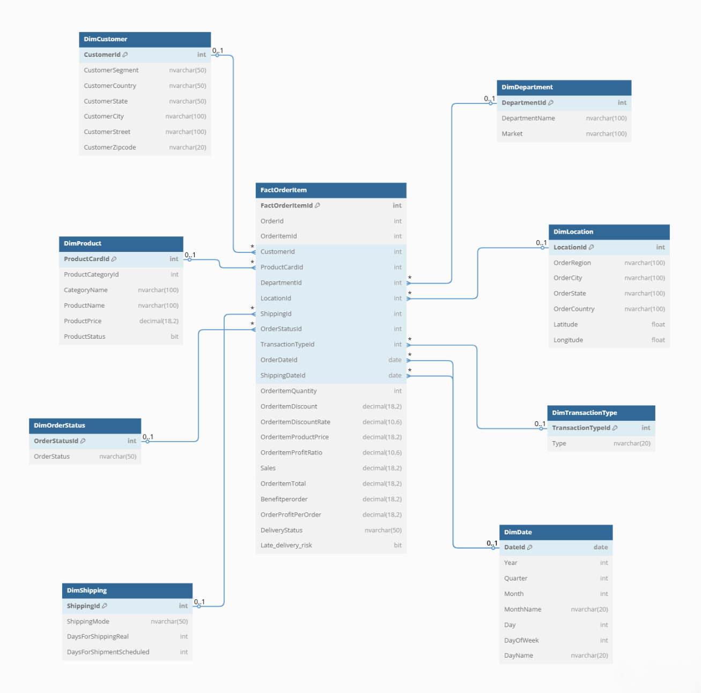
Figure 1 ER DIAGRAM

